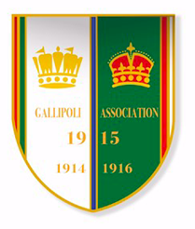

**The Warwicks in Gallipoli,**

**Monday 16th September 10am – 4pm.**

Join us for a FREE event to commemorate the Warwickshire soldier in the Gallipoli campaign. Soldiers from the Royal Warwickshire Regiment (the 9th Battalion) and the Warwickshire Yeomanry fought in the conflict. Discover tales of heroism and sacrifice. See treasures from this ill-fated campaign on display in a special exhibition.

There will be a short wreath laying service, to honour the fallen, at St. Mary’s Church, Old Square, Warwick, CV34 4RA, commencing at 12.00.

Ian Binnie, from the Gallipoli Association, will give an illustrated talk, ‘Warwickshire Soldiers and Gallipoli' at 10.30 am at the Yeomanry Museum and at 2 pm at the Fusilier Museum.

Warwickshire Yeomanry Museum, The Court House, Jury Street, Warwick, CV34 4EW (entrance in Castle Street).

Fusilier Museum, St John’s House, Warwick, CV34 4NF

